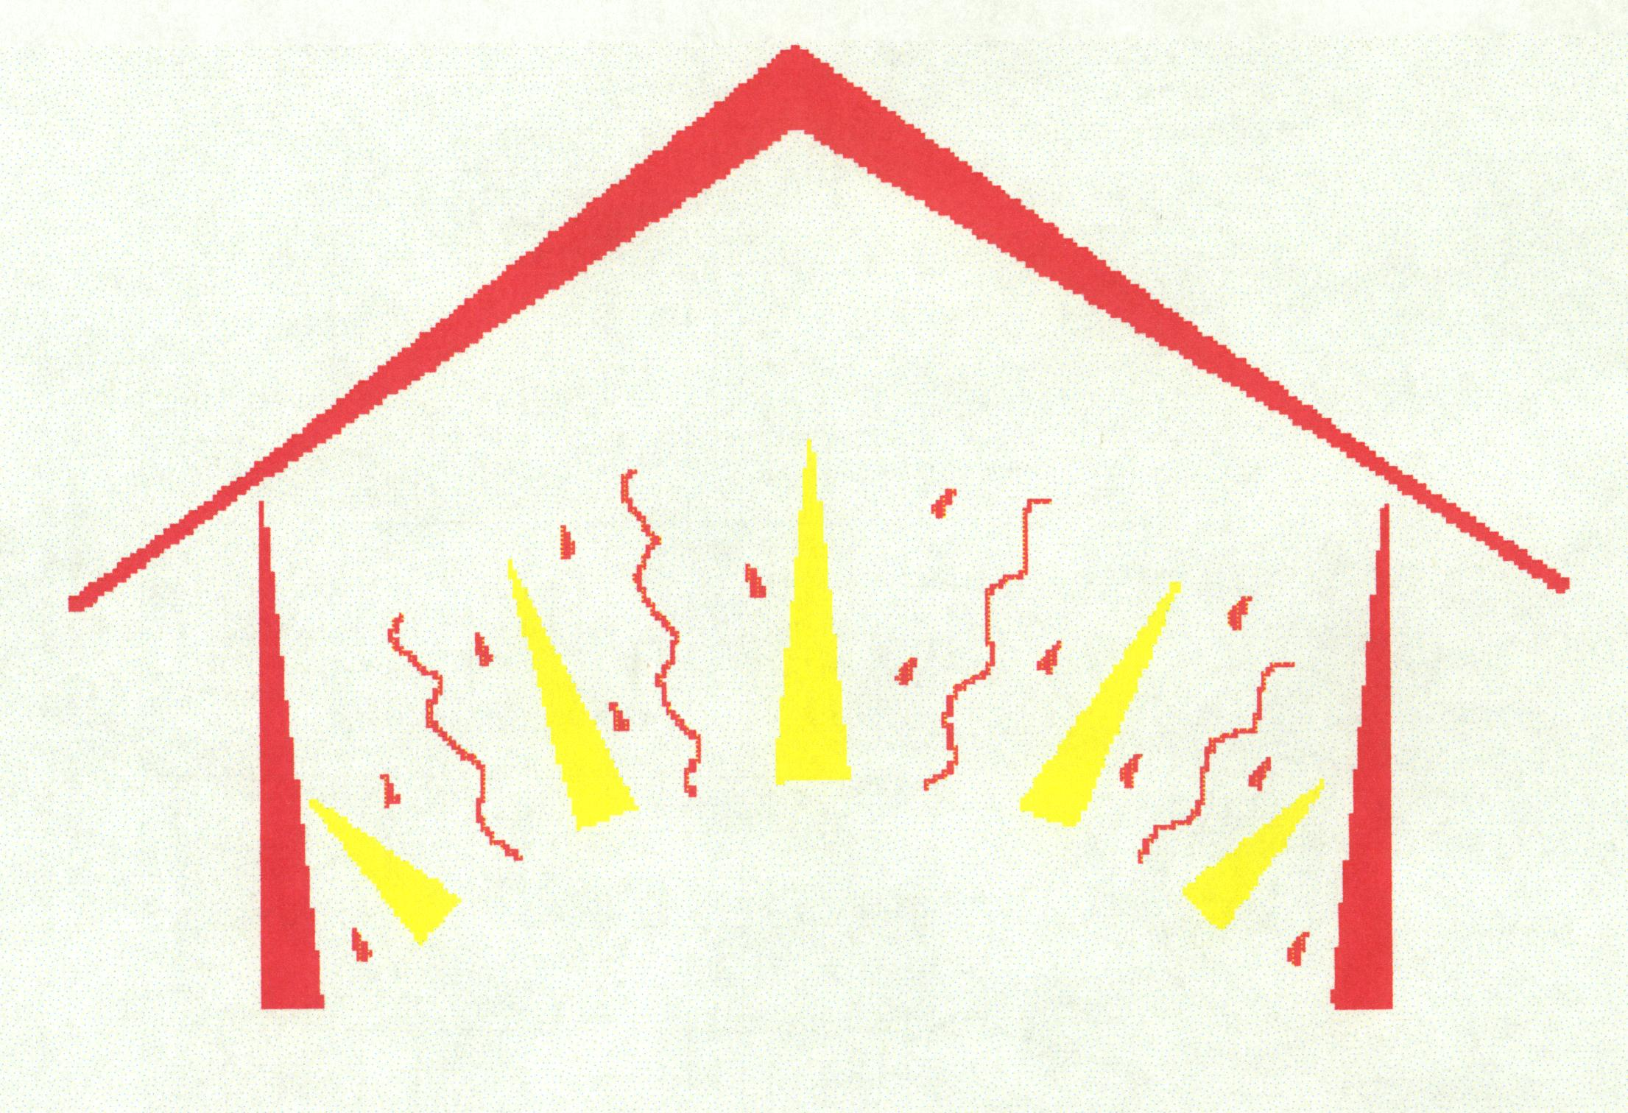
Energy Share of Montana
318 N. Last Chance Gulch Ste. 2B, Helena, MT 59601
406-442-4900 or 1-800-777-7589

- Energy Share of Montana has helped 4,900 families through its low-income Universal Systems Benefits programs.

- Energy Share is a statewide private nonprofit organization that has been around since 1982.
- We raise and distribute funds in the private sector to help people who are facing energy emergencies, which usually means someone facing a utility termination notice or empty propane tank, and they have no way to pay for it themselves.

- Energy Share complements the LIEAP program. Assistance is usually once-in-a-lifetime, or a maximum of $500. Examples of the types of families helped include:
- Those who have lost a job or time at work (often for medical reasons) and used up whatever savings they had;
- The working poor who have a vehicle break down and need to choose between repairing their car or paying a bill; or
- Senior citizens on fixed incomes who simply do not have enough money coming in to meet all their needs.

- Since 1982 Energy Share has helped 20,000 such families with 5.8 million dollars.

- The number of families Energy Share can help has more than doubled, thanks to USB.
- In fiscal year 1998 before any USB funding, Energy Share helped 931 families with $234,000.
- In fiscal year 2003 because of USB funding, that jumped to 1,824 families with $534,000.

- Energy Share only has the funding to help a small percentage of the number of poor in Montana.
- According to the 2000 census figures there are 90,789 Montana households below 150% of poverty, and we helped 2% of those.
- Even when LIEAP assistance is considered, which helped 17,550 households in FY03, between LIEAP and Energy Share only 21% of Montana’s low-income or working poor were helped.
- The 1990 Census reported 213,392 people below 150% of poverty, compared to 225,447 in the 2000 Census – a growth of over 12,000.
- In 2002 there were over $14 million USB dollars collected.
- While the amount of money Energy Share receives may seem small compared to total USB expenditures, there are still 1,171 Montana families who were able to keep their heat on last year due to Energy Share’s USB funding.
- $3.2 million (23%) of the $14 million collected went to low-income purposes, and of that Energy Share received about $554,405 for low-income programs.

